Switching Circuits
Example 1
Here is a switch called. It can be closed or open.


Ifis closed then electric current can flow. We say
Ifis open then electric current cannot flow. We say

Example 2
Here are two switches in series:

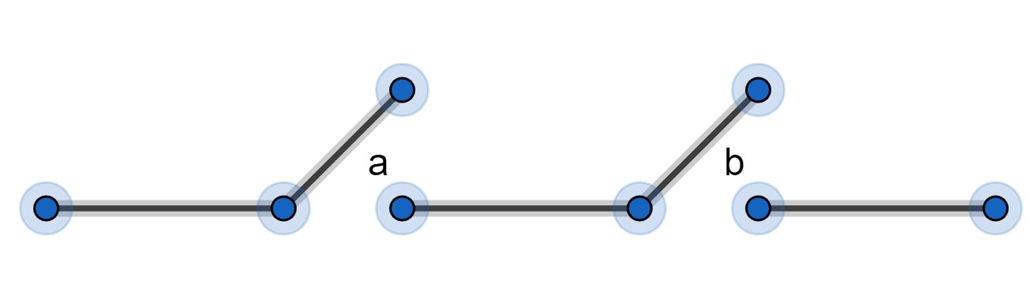

denotes switchesandin series (this is not multiplication!)
Ifis closed andis closed then electric current can flow.
So ifandthenSo
Ifis open oris open (or both) then electric current cannot flow.
So ifor(or both) thenSo

We can set this out in a table:
0 | 0 | 0
0 | 1 | 0
1 | 0 | 0
1 | 1 | 1

Example 3
Here are two switches in parallel:

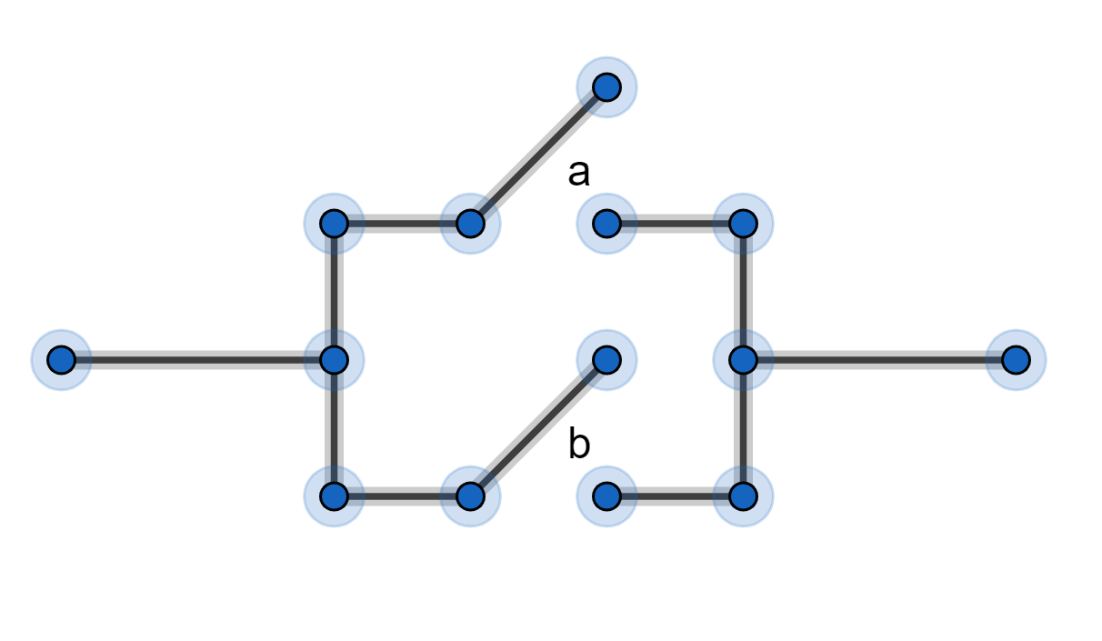

denotes switchesandin parallel (this is not addition!)
is closed oris closed (or both) then electric current can flow.
So ifor(or both) thenSo
Ifis open andis open then electric current cannot flow.
SoifandthenSo

We can set this out in a table:
0 | 0 | 0
0 | 1 | 1
1 | 0 | 1
1 | 1 | 1

We can have switches that are linked to each other. If two switches are both calledthen they are always in the same state, either both open or both closed. If one switch is calledand another switch is calledthen they are always in opposite states, one open and the other one closed.
IfthenIf then

Example 4
Here is a circuit:
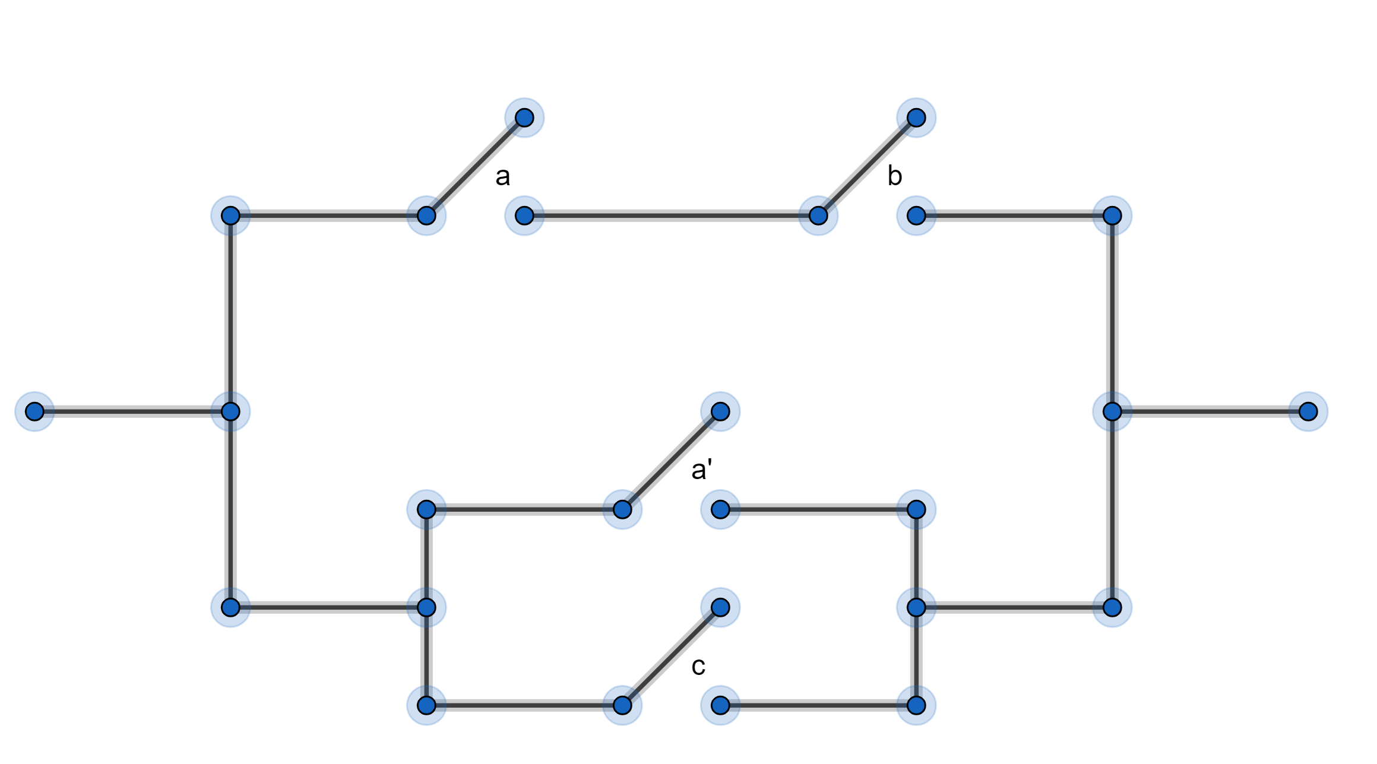

The mathematical expression for this circuit is: Think about it.
The table for this circuit is:
0 | 0 | 0 | 0 | 1 | 1 | 1
0 | 0 | 1 | 0 | 1 | 1 | 1
0 | 1 | 0 | 0 | 1 | 1 | 1
0 | 1 | 1 | 0 | 1 | 1 | 1
1 | 0 | 0 | 0 | 0 | 0 | 0
1 | 0 | 1 | 0 | 0 | 1 | 1
1 | 1 | 0 | 1 | 0 | 0 | 1
1 | 1 | 1 | 1 | 0 | 1 | 1

see EXERCISE 1

Look at Exercise 1 questions (4) and (5)
You should have found that the columns forandare the same.
We say
The circuit in (5) does the same thing as the circuit in (4) but uses fewer switches.

denotes switchin series with a closed switch
electric current can flow ifis closed, soif
electric current cannot flow ifis open, soif
So

denotes switchin parallel with a closed switch. Electric current can always flow.
So

denotes switchin series with an open switch. Electric current can never flow.
So

denotes switchin parallel with an open switch
electric current can flow ifis closed, soif
electric current cannot flow ifis open, soif
So

Use tables to prove the following rules: (no need to do them all)

EXERCISE
1) Draw the circuit and fill in the table for
a | b
0 | 0
0 | 1
1 | 0
1 | 1

2) Draw the circuit and fill in the table for
a | b
0 | 0
0 | 1
1 | 0
1 | 1

3) Draw the circuit and fill in the table for
a | b | c
0 | 0 | 0
0 | 0 | 1
0 | 1 | 0
0 | 1 | 1
1 | 0 | 0
1 | 0 | 1
1 | 1 | 0
1 | 1 | 1

4) Draw the circuit and fill in the table for
a | b | c
0 | 0 | 0
0 | 0 | 1
0 | 1 | 0
0 | 1 | 1
1 | 0 | 0
1 | 0 | 1
1 | 1 | 0
1 | 1 | 1

5) Draw the circuit and fill in the table for
a | b | c
0 | 0 | 0
0 | 0 | 1
0 | 1 | 0
0 | 1 | 1
1 | 0 | 0
1 | 0 | 1
1 | 1 | 0
1 | 1 | 1

SOLUTIONS
1)
a | b
0 | 0 | 0 | 0 | 0
0 | 1 | 1 | 0 | 1
1 | 0 | 1 | 0 | 1
1 | 1 | 1 | 1 | 1

Here is the circuit. Can you label the switches?
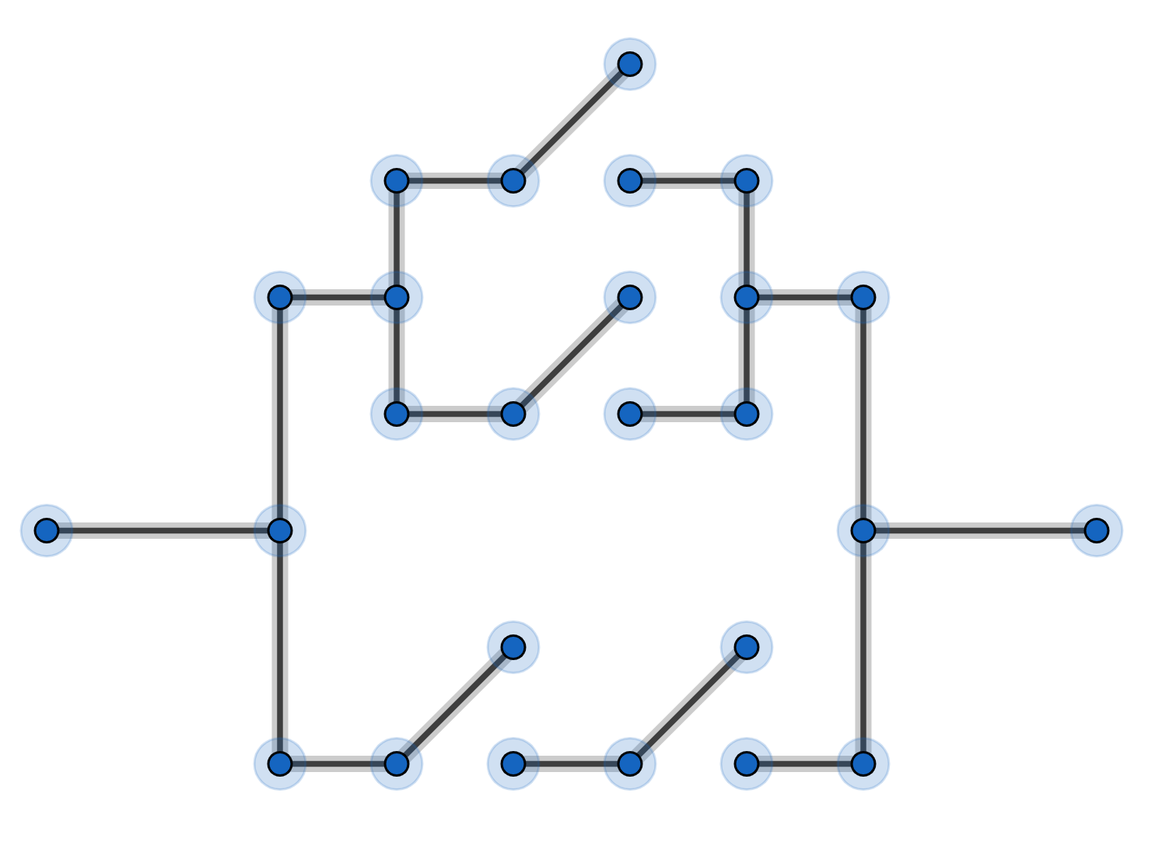

2)
a | b
0 | 0 | 1 | 1 | 0
0 | 1 | 1 | 1 | 0
1 | 0 | 0 | 0 | 0
1 | 1 | 0 | 1 | 1

Here is the circuit. Can you label the switches?
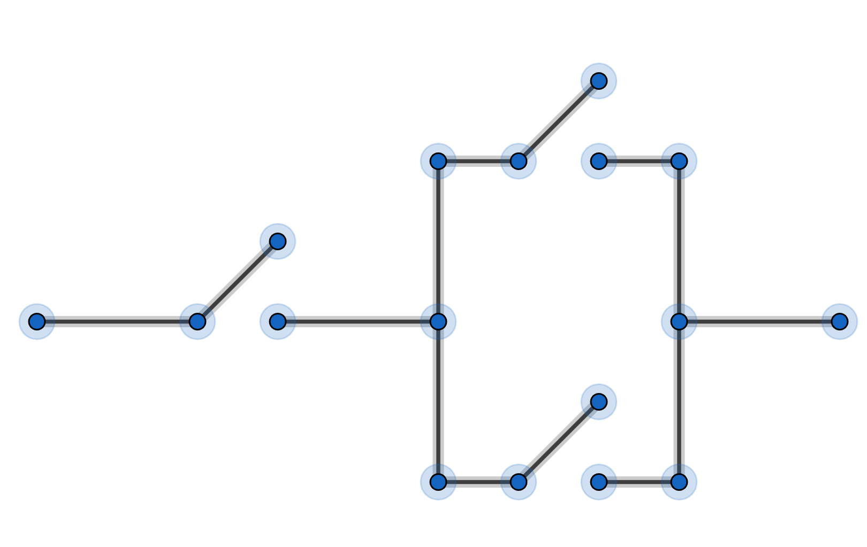

3)
a | b | c
0 | 0 | 0 | 0 | 0
0 | 0 | 1 | 0 | 1
0 | 1 | 0 | 0 | 0
0 | 1 | 1 | 0 | 1
1 | 0 | 0 | 0 | 0
1 | 0 | 1 | 0 | 1
1 | 1 | 0 | 1 | 1
1 | 1 | 1 | 1 | 1

Here is the circuit. Can you label the switches?
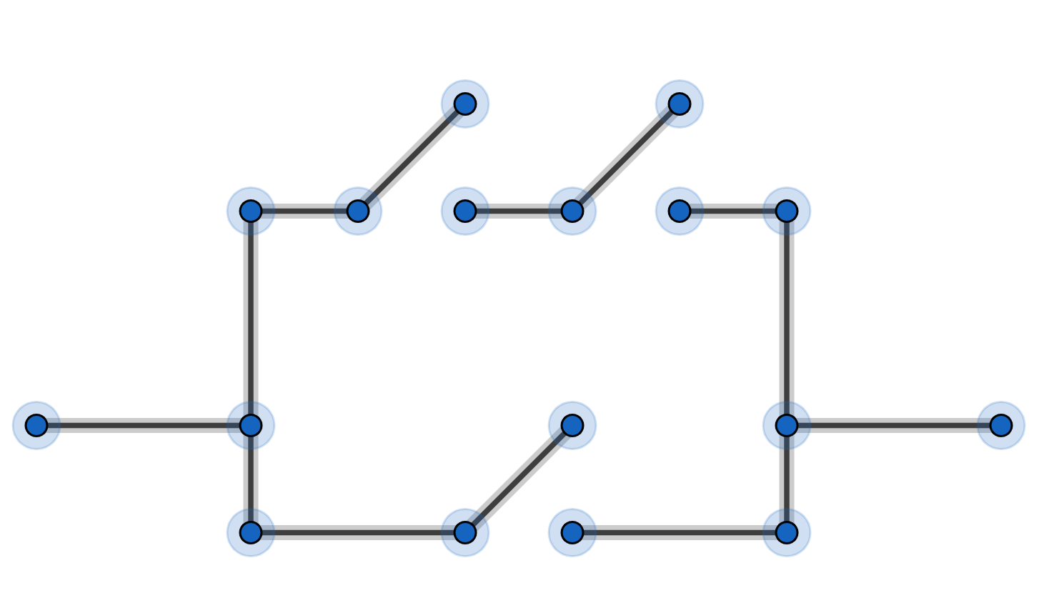

4)
a | b | c
0 | 0 | 0 | 0 | 0 | 0
0 | 0 | 1 | 0 | 0 | 0
0 | 1 | 0 | 0 | 0 | 0
0 | 1 | 1 | 0 | 0 | 0
1 | 0 | 0 | 0 | 0 | 0
1 | 0 | 1 | 0 | 1 | 1
1 | 1 | 0 | 1 | 0 | 1
1 | 1 | 1 | 1 | 1 | 1

Here is the circuit. Can you label the switches?
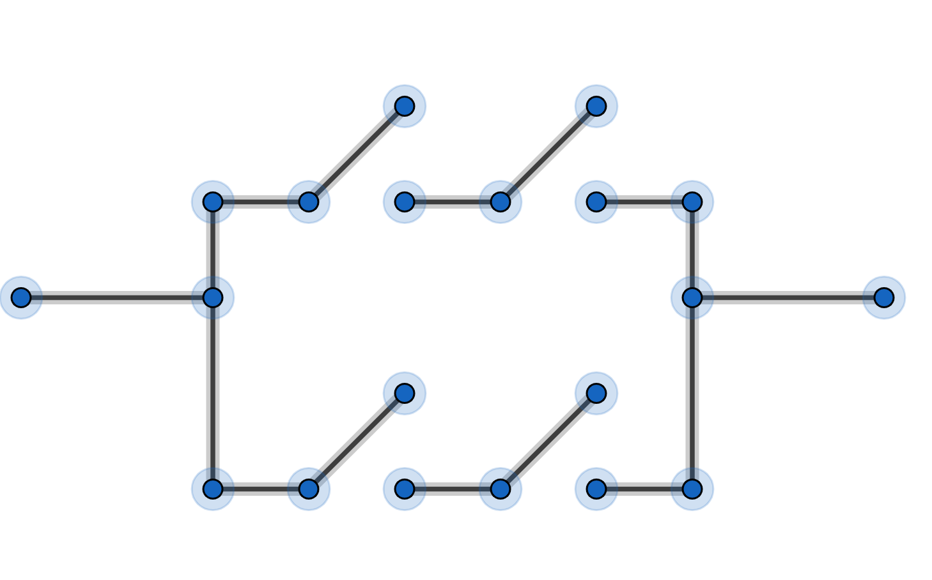

5)
a | b | c
0 | 0 | 0 | 0 | 0
0 | 0 | 1 | 1 | 0
0 | 1 | 0 | 1 | 0
0 | 1 | 1 | 1 | 0
1 | 0 | 0 | 0 | 0
1 | 0 | 1 | 1 | 1
1 | 1 | 0 | 1 | 1
1 | 1 | 1 | 1 | 1

Here is the circuit. Can you label the switches?

